Emotional Fuel Checklist
The following questions would help you in estimating the 'energy balance to fuel EI.
Put a tick () mark if you completely agree to the statement or else a cross (X) mark
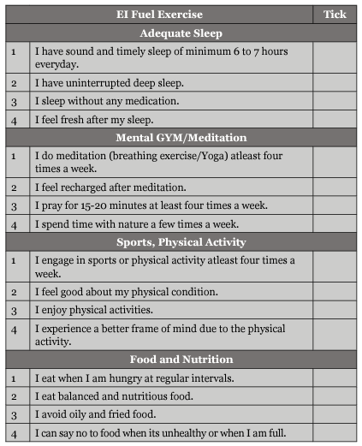
Compliment yourself for statements which are marked ().
Introspect and develop an action plan on the basis of the rest of the statements.

